**Injecting Values from Properties File**

**Injecting Values from Properties File**:

Now we inject values from a properties file by using Java configuration. We will make use of our SwimCoach and we’ll also use as properties file.

We read the value from a properties file and inject them in SwimCoach to make use of.

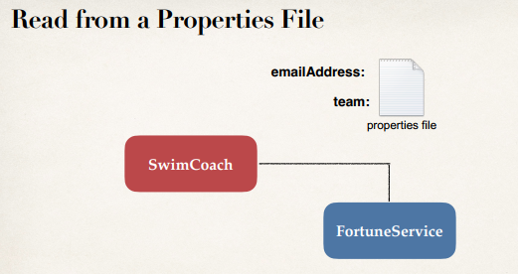

**Development process**:

1. Create Properties File
2. Load Properties File in Spring config
3. Reference values from Properties File

**Step 1: Create Properties File**:

**File: sport.properties**:

foo.email=myeasycoach@luv2code.com

foo.team=Awesome Java Coders

**Step 2: Load Properties file in Spring config**:

**File: SportConfig.java**:

@Configuration

@PropertySource("classpath:sport.properties")

public class SportConfig {

…

}

**Step 3: Reference Values from Properties File**:

**File: SwimCoach.java**:

public class SwimCoach implements Coach {

@Value("${foo.email}")

private String email;

@Value("${foo.team}")

private String team;

...

}

**Example**:

**File: Coach.java**:

**package** com.ruhul.odduu.valuefromproperty;

**public** **interface** Coach {

**public** String getDailyWorout();

**public** String getDailyFortune();

}

**File: FortuneService.java**:

**package** com.ruhul.odduu.valuefromproperty;

**public** **interface** FortuneService {

**public** String getFortune();

}

**File: SadFortuneService.java**:

**package** com.ruhul.odduu.valuefromproperty;

**public** **class** SadFortuneService **implements** FortuneService {

@Override

**public** String getFortune() {

**return** "Today is a sad day";

}

}

**File: sport.properties**:

Create a "sport.properties" in the location "src/sport.properties"

foo.email = ruhulodduu@gmail.com

foo.team = Awesome Java Coders

**File: SwimCoach.java**:

**package** com.ruhul.odduu.valuefromproperty;

**import** org.springframework.beans.factory.annotation.Value;

**public** **class** SwimCoach **implements** Coach {

**private** FortuneService fortuneService;

@Value("${foo.email}")

**private** String email;

@Value("${foo.team}")

**private** String team;

// constructor

**public** SwimCoach(FortuneService fortuneService) {

**this**.fortuneService = fortuneService;

}

@Override

**public** String getDailyWorout() {

**return** "Swim 1000 meters as a warm up";

}

@Override

**public** String getDailyFortune() {

**return** fortuneService.getFortune();

}

**public** String getEmail() {

**return** email;

}

**public** String getTeam() {

**return** team;

}

}

**File: SportConfig.java**:

**package** com.ruhul.odduu.valuefromproperty;

**import** org.springframework.context.annotation.Bean;

**import** org.springframework.context.annotation.Configuration;

**import** org.springframework.context.annotation.PropertySource;

@Configuration

@PropertySource("classpath:sport.properties")

**public** **class** SportConfig {

// define bean for our SadFortuneService

// the method name("sadFortuneService") will be the bean ID

@Bean

**public** FortuneService sadFortuneService() {

**return** **new** SadFortuneService();

}

// define bean for our SwimCoach and inject dependency

@Bean

**public** Coach swimCoach() {

**return** **new** SwimCoach(sadFortuneService());

}

}

**File: SwimJavaConfigDemoApp.java**:

**package** com.ruhul.odduu.valuefromproperty;

**import** org.springframework.context.annotation.AnnotationConfigApplicationContext;

**public** **class** SwimJavaConfigDemoApp {

**public** **static** **void** main(String[] args) {

// read spring configuration java class

AnnotationConfigApplicationContext context = **new** AnnotationConfigApplicationContext(SportConfig.**class**);

// retrieve bean from spring container

SwimCoach swimCoach = context.getBean("swimCoach", SwimCoach.**class**);

// call a method on the bean

System.***out***.println(swimCoach.getDailyWorout());

// call a method to the daily fortune

System.***out***.println(swimCoach.getDailyFortune());

// call our SwimCoach methods... has the props values injected

System.***out***.println("Email: " + swimCoach.getEmail());

System.***out***.println("Team: " + swimCoach.getTeam());

// close the context

context.close();

}

}

/*

**Output**:

Swim 1000 meters as a warm up

Today is a sad day

Email: ruhulodduu@gmail.com

Team: Awesome Java Coders

*/